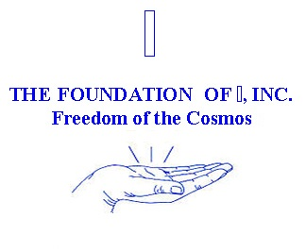

Self I-Dentity through Ho’oponopono® Book order form:

These books may be ordered without having taken an IZI LLC sponsors SITH® class.
Limit 10 books per order. For books of 11+ please email: order@hooponopono.org for a shipping rate.

COVID 2019: Please note: some countries are not receiving shipping from the US: please check the list below before ordering. https://about.usps.com/newsroom/service-alerts/international/welcome.htm
Description |  | Price | Quantity |  | Total
Dewdrops of Wisdom |  | 30.00
Seasons of the Mind |  | 30.00
Subtotal
Domestic Shipping 1-6 books First Class ($9), 7-10 books ($15)
Domestic Shipping 1-6 books Priority ($10), 7-10 books ($20)

International Shipping 1-6 books First Class ($35), 7-10 books ($55)
International Shipping 1-6 books Priority ($50), 7-10 books ($75)
Total Amount Due

Name: ___________________________________________________________
Address: _________________________________________________________
City/State/Country: _________________________________________________
Zip code: _________________
Phone: ___________________
E-mail: ___________________
Date: _____________________

USD Check or money orders are made payable to:
The Foundation of I, Inc Freedom of the Cosmos, 87-344 Kulahanai St., Waianae, HI 96792
Please refer to the Policies and Procedures page for shipping and handling information.

